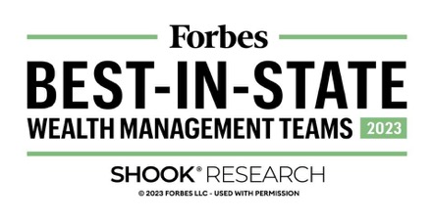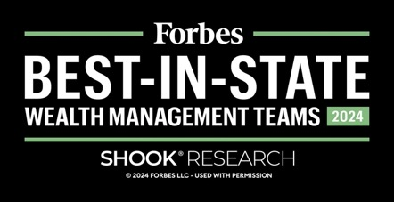

2023 Forbes Best-in-State Wealth Management Teams
The Forbes Best-in-State Wealth Management Teams rating algorithm is based on the previous year’s industry experience, interviews, compliance records, assets under management, revenue and other criteria by SHOOK Research, LLC. Investment performance is not a criterion. Self-completed survey was used for rating. This rating is not related to the quality of the investment advice and based solely on the disclosed criteria.
2024 Forbes Best-in-State Wealth Management Teams
The Forbes Best-in-State Wealth Management Teams rating algorithm is based on the previous year’s industry experience, interviews, compliance records, assets under management, revenue and other criteria by SHOOK Research, LLC. Investment performance is not a criterion. Self-completed survey was used for rating. This rating is not related to the quality of the investment advice and based solely on the disclosed criteria.
PM-09072025-6463597.1.1

